**DBMS LAB ASSIGNMENT - 5**

**NAME : R. DHATRI KIRAN**

**ROLL NO. : 19BCS093**

Q1) Illustrate logical ANY, ALL and LIKE operator- the queries should be relevant to your

respective databases 3 queries for each operator. One query explaining the difference between ANY and ALL.

QUERIES FOR “ANY”

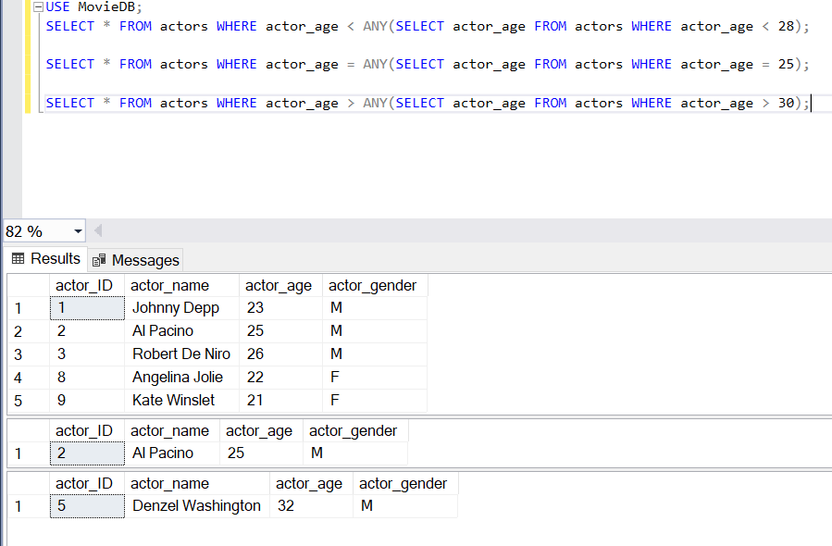

QUERIES FOR “ALL”

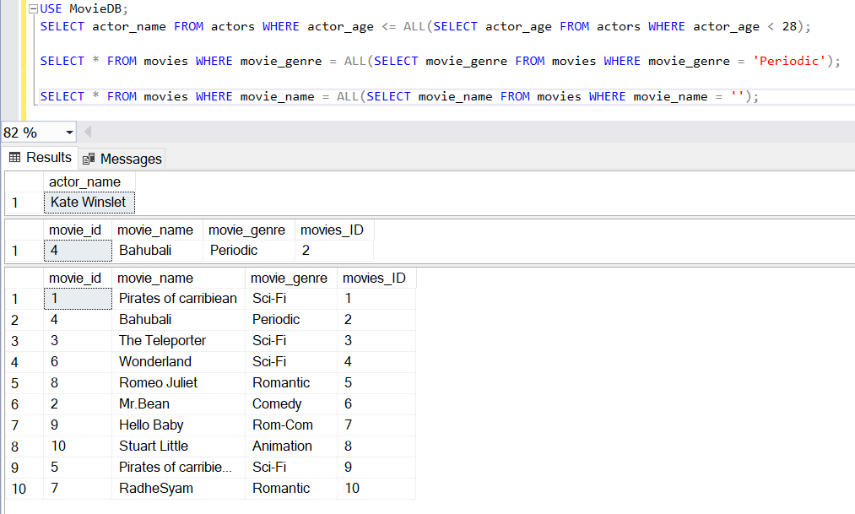

QUERIES FOR “LIKE”

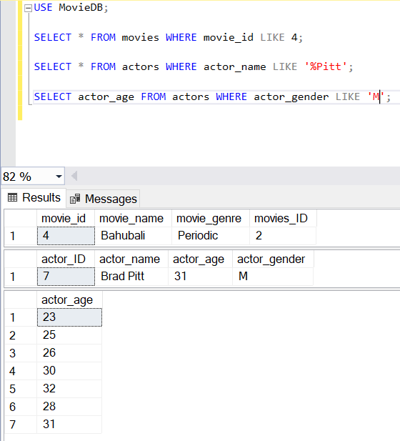

Q2) One query for each Aggregate function.

The aggregate functions are MIN(), MAX(), COUNT(), AVG(), SUM()

AVG() – return the average of the set

MIN() – returns the minimum value in a set

MAX() – returns the maximum value in set

SUM() – returns the sum of all distinct values of a set

COUNT() – returns the number of items in a set

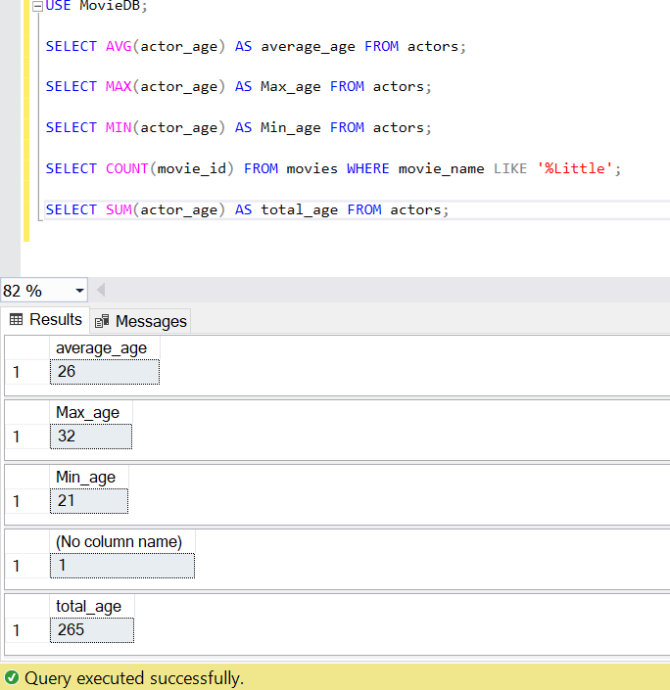

Q3) Illustrate the usage of order by, group by and having clause (2 queries for each case)

ORDER BY

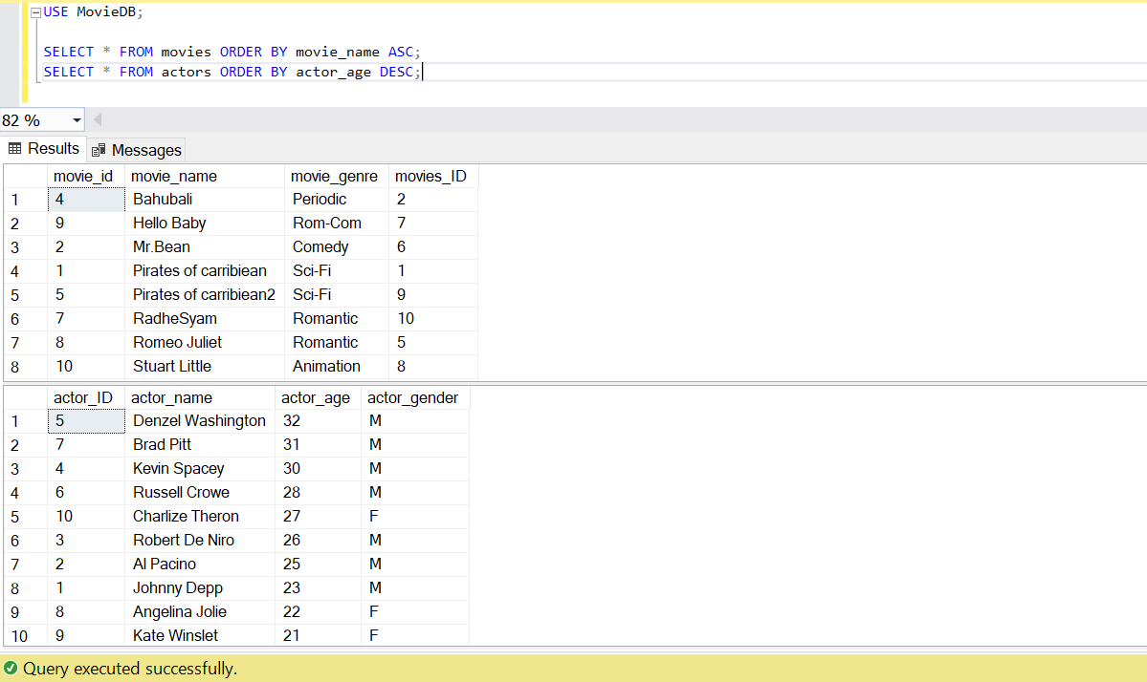

GROUP BY

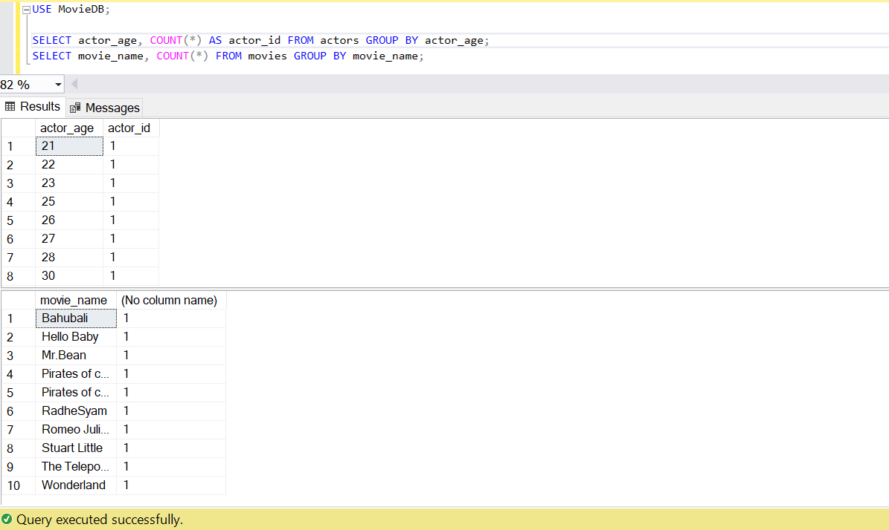

HAVING CLAUSE

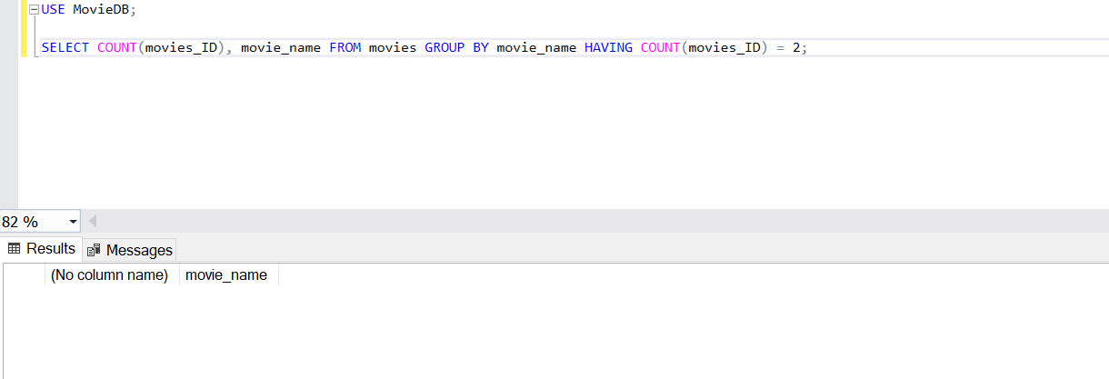

Q4) Use Aggregate function with group by and having

AVG():

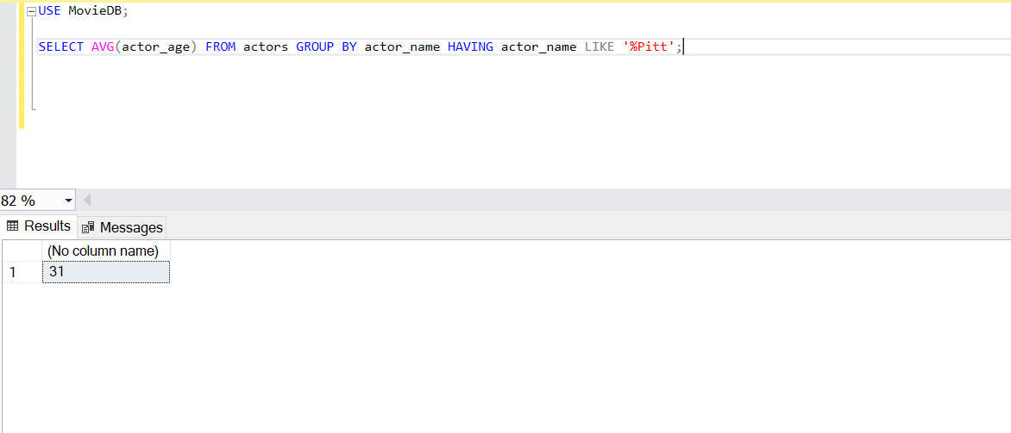

COUNT():

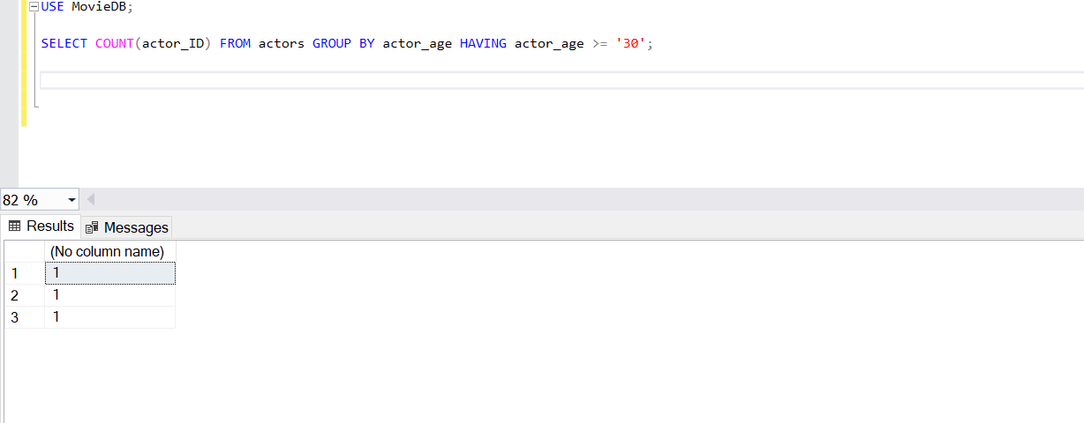

MIN():

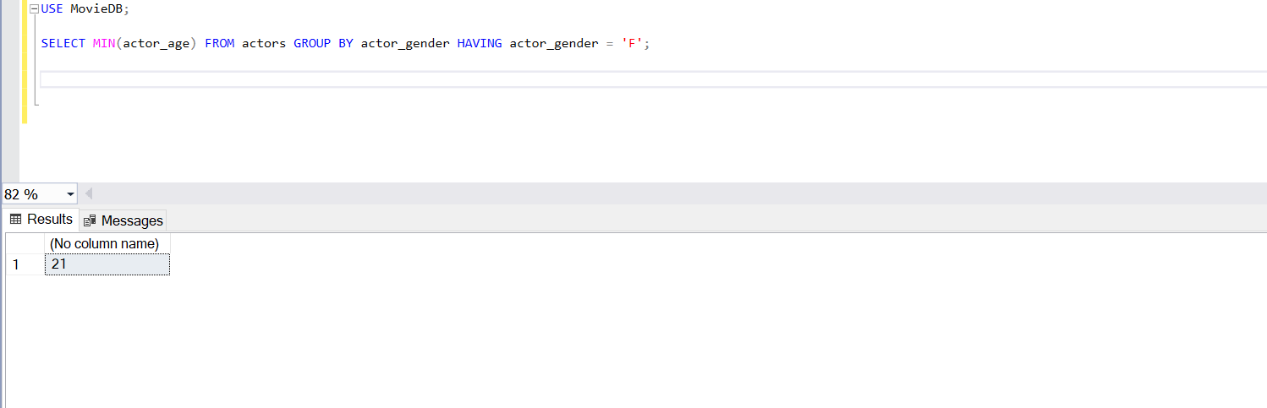

MAX():

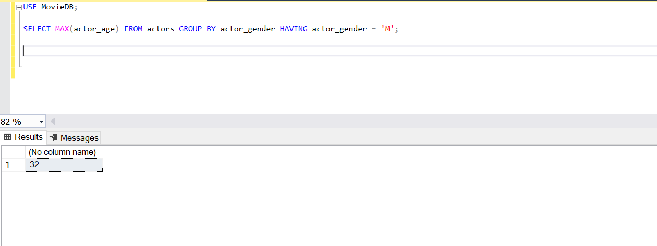

SUM():

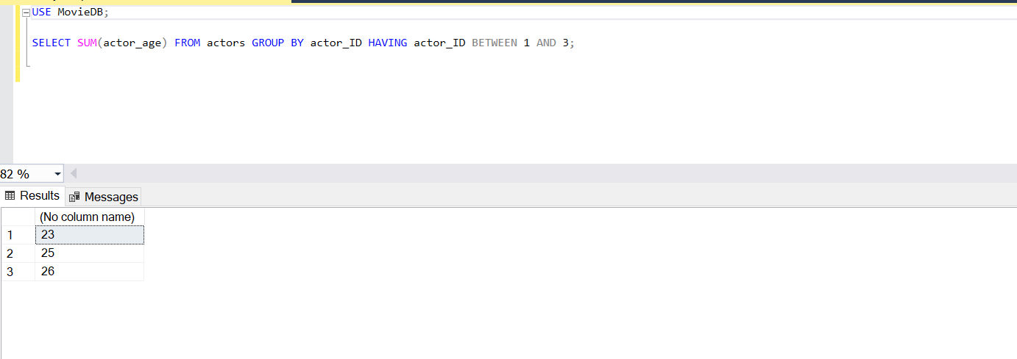

Q5) Write at least 3 nested queries using order by, group by and having clause.

QUERY:

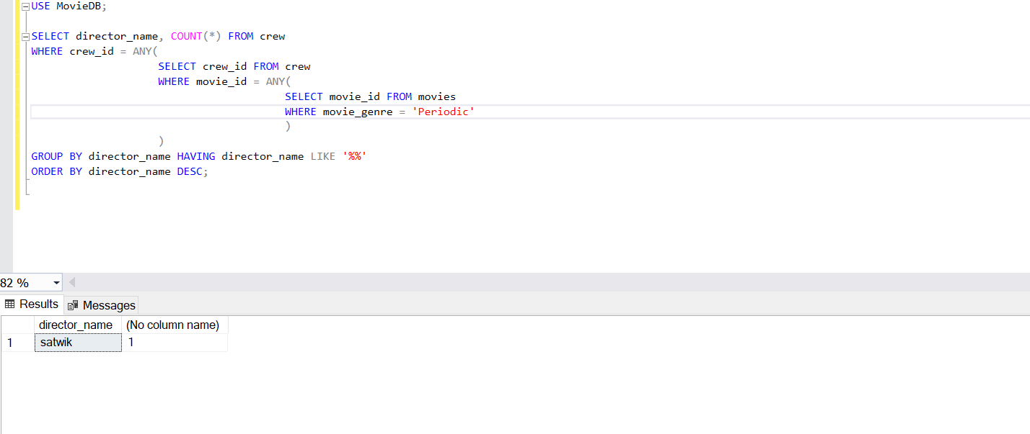

Q6) Illustrate the Usage of Except, Exists, Not Exists, Union, Intersection

EXCEPT():

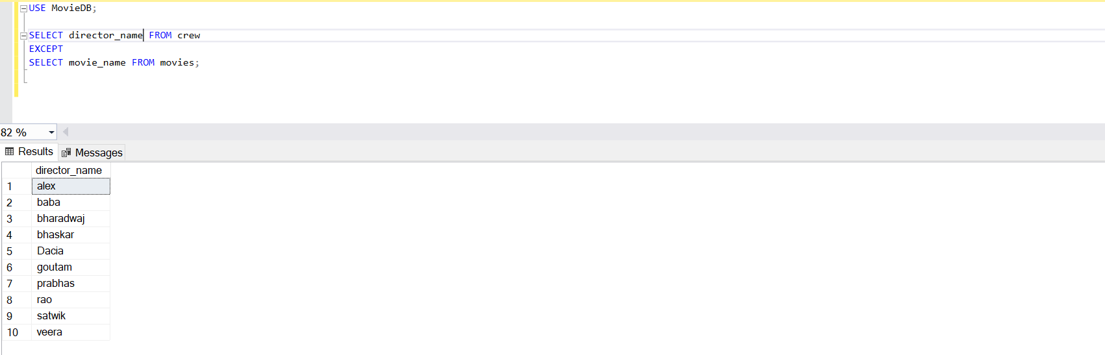

EXISTS():

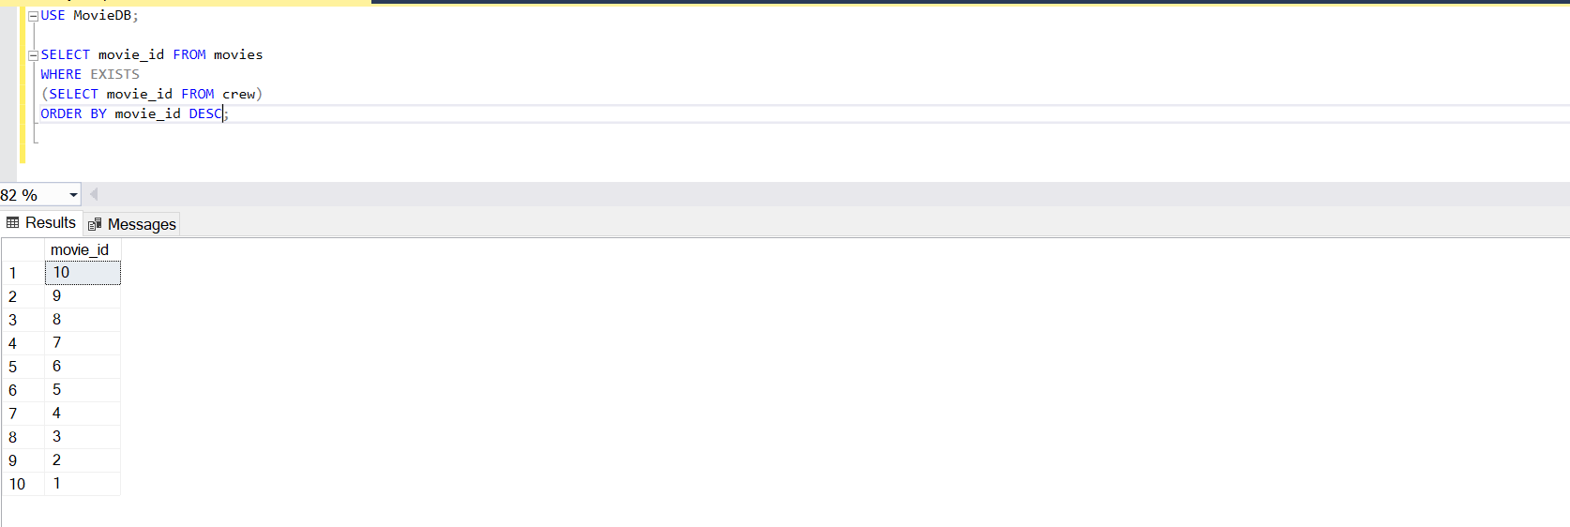

NOT EXISTS():

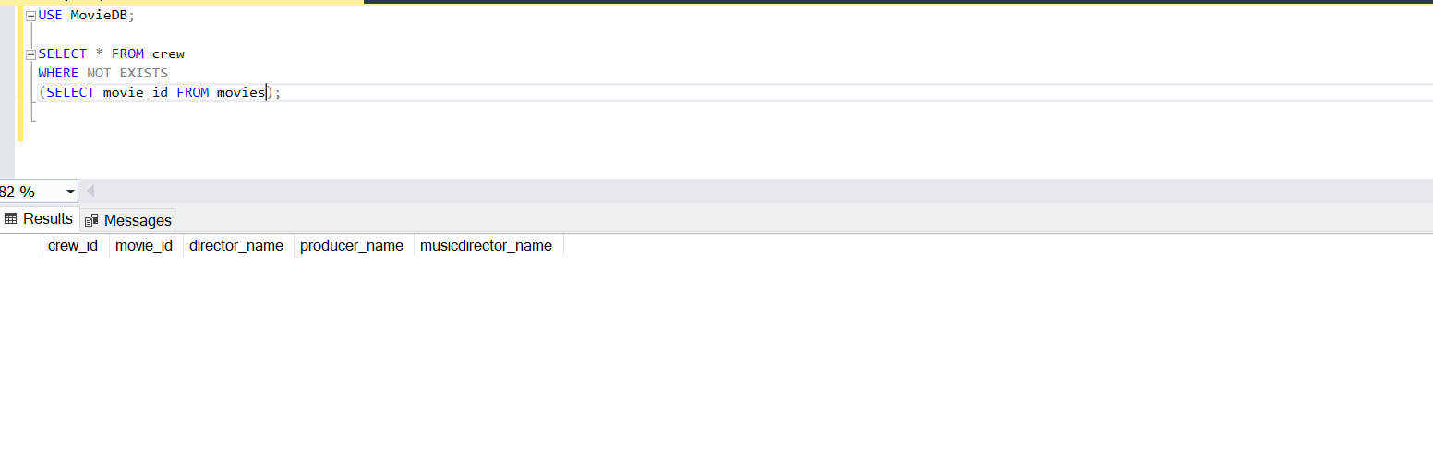

UNION():

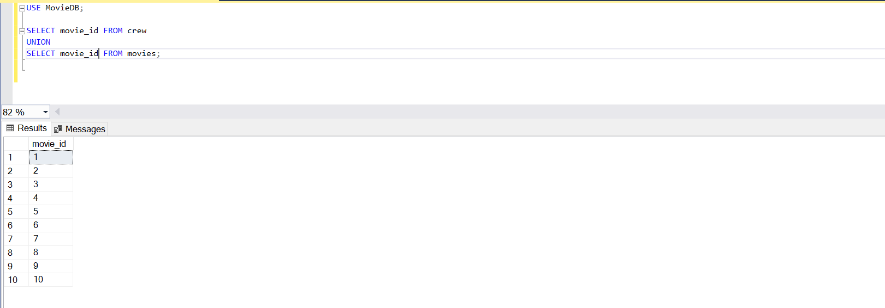

INTERSECT():

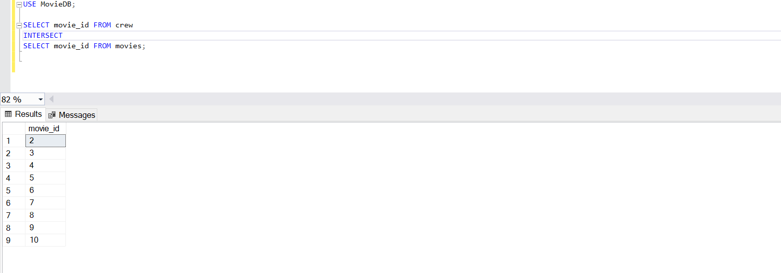

Q7) INNER JOIN, LEFT OUTER JOIN, RIGHT OUTER JOIN- 3 queries for each instance

INNER JOIN

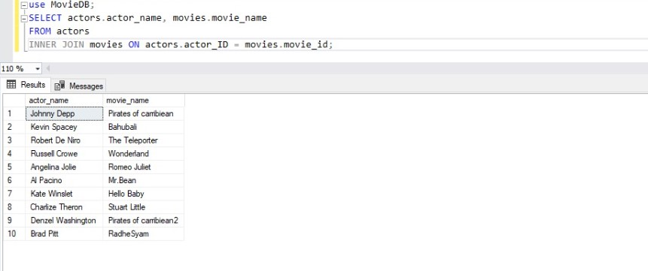

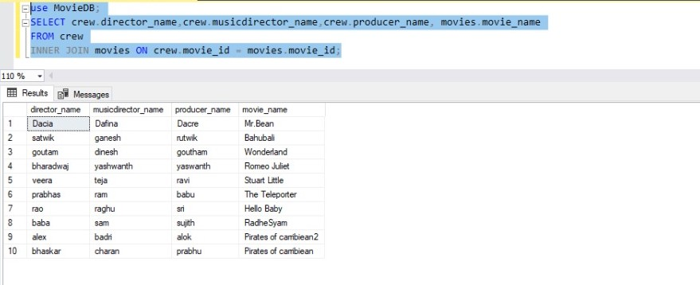

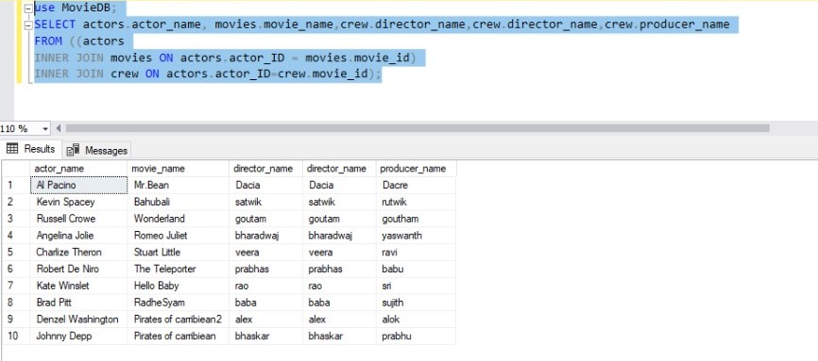

**LEFT OUTER JOIN**

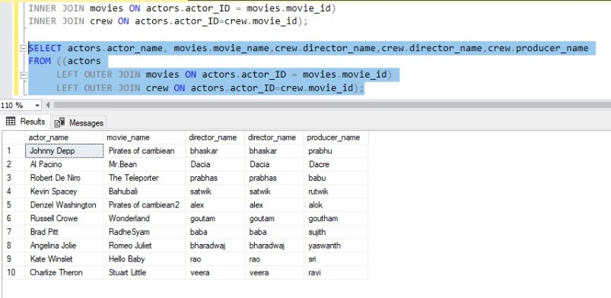

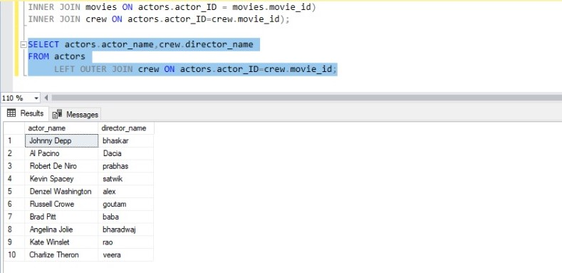

**RIGHT OUTER JOIN**

